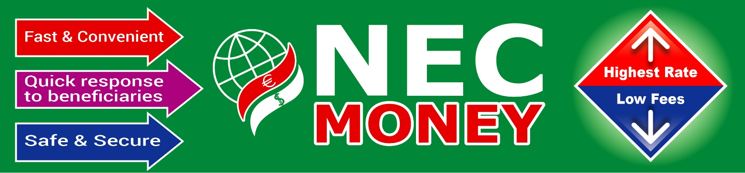

**Agent Registration From**

Picture

Name :

Fathers Name :

Bate of Birth : Birth City :______________Birth Country :_______________________

Nationality :

Division/Region : City/District :______________ City/District Code :_____________

State/Province : State/Province Code : _________ Post Code :________________

Mobile Number :

TNT Phone Number :

Fax Number :

E-mail Number :

Contract Person :

Address :_________________________________________________________________________

_________________________________________________________________________

_________

**Signature**

Head Office Address: NEC Money Transfer Limited. 356,High Street North, London, E12 6PH, United Kingdom.